Create local directory on the VM:-

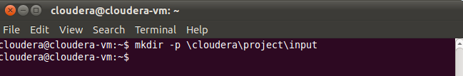

Transfer the data using Filezilla from windows to VM on local FS.

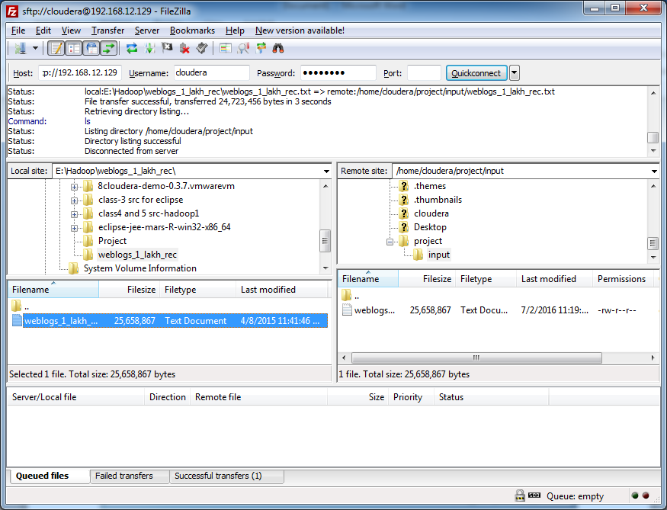

Create a HDFS directory:-

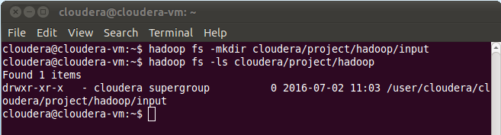

Load the data from local FS into HDFS:-

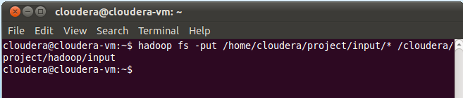

Browse through local file system:-

